5.2.1 Line Integrals Worksheet

- Let C be the curve in parameterized by for .
- Evaluate the integral .

- Evaluate the integral .

- Evaluate the integral .

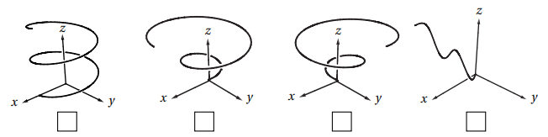
- Mark the picture of the curve in parameterized by for .
- Let C be the curve parameterized by for .
- Compute .

- Compute .

- Find the mass of a thin wire in the shape of the curve where , if the wire has density function .

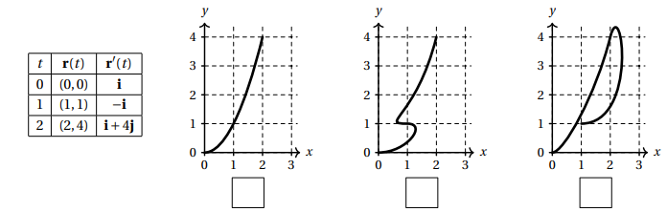
- Suppose that is a parametric curve in the plane and that and have the values given in the table at left. Check the box below the picture that could be a plot of .
- Let C be the oriented curve parameterized by where .
- Check the box next to the picture which best matches C.
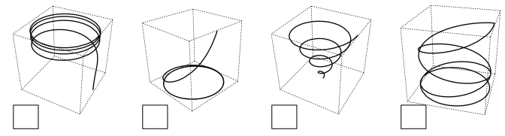

- Calculate the line integral

- Calculate the line integral .

- Suppose a wire can be modeled by the segment of the circle from to , when moving counterclockwise. If the linear density of this wire is measured by for any point on the wire, then set up an integral which represents the mass of this wire.

- Let , and C be a curve which is the intersection of the surfaces and from to . Compute the line integral .

- Evaluate the line integral , where C is the arc of the curve from to .

- Consider the line integral , where C is the arc of the curve parameterized by from .
- Evaluate .

- Evaluate .

- Evaluate the line integral , where C consists of the arc of the circle from to followed by the line segment from to .

- Evaluate the line integral , where C consists of the line segments from to and from to .

